Clone A Repository

Below are instructions for how to clone a repository, thats GitHub lingo for making a directory on your computer that is linked to your repository on GitHub. Before you clone, you might need to consider Forking follow the questions belore:

* Did you create this repository?
  + Don’t fork it
* Is this a repository for our group or the open force field group?
  + Don’t fork it
* Is this a repository for another collaboration?
  + Are you going to make changes to the code?
    - You should check the owners development policy before you clone, you might need to [fork it](https://docs.google.com/document/d/1qdRfO4hkexBoxear9YPCUxfkwz0Luv0R3F3DF9zqF-c/edit?usp=sharing).
  + You’re just going to use the code and have no plans to make changes?
    - Don’t fork it.
* Is this a repository from a completely outisde group?
  + Are you going to make changes to the code?
    - [Fork It](https://docs.google.com/document/d/1qdRfO4hkexBoxear9YPCUxfkwz0Luv0R3F3DF9zqF-c/edit?usp=sharing)
  + Not changing the code:
    - You don’t need to fork it, but you might want to consider downloading a specific version of the code rather than cloning a repository that is in development.

We have a file describing how to fork a repository [here](https://docs.google.com/document/d/1qdRfO4hkexBoxear9YPCUxfkwz0Luv0R3F3DF9zqF-c/edit?usp=sharing).

# Cloning?

There is a button on the top of your repository’s webiste for “Clone or download”

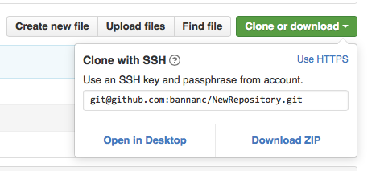

* You’ll want to copy the ssh key
* Move to your terminal and enter the command
  + Git clone [paste copied key here]
  + You should see something like this output:

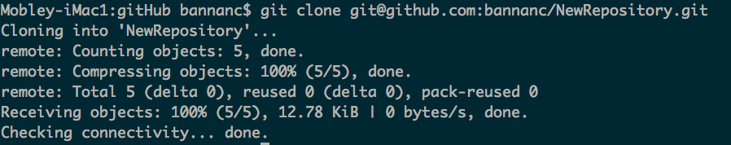

This process will create a directory with the name of your repository, you can cd into it and then start [working locally](https://docs.google.com/document/d/1Ivk_IHnZd862YWdlppmqpU_0VRKY9FbbAOZ-XNC-TN8/edit?usp=sharing)